1. Now time to install a tool **OpenSSL** that allows us to generate RSA Keys to create a certificate signing request for a new certificate.
2. MAC has by default. This lecture is for windows users.
3. 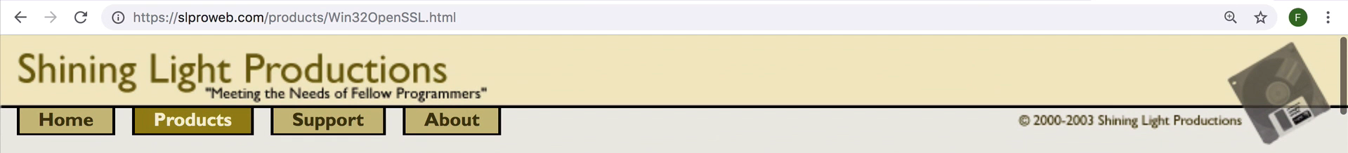 A screenshot of a computer

   Description automatically generated
4. <https://slproweb.com/products/Win32OpenSSL.html>